Killeigh (KEHB)
Wednesday 18 March 2026
10:25
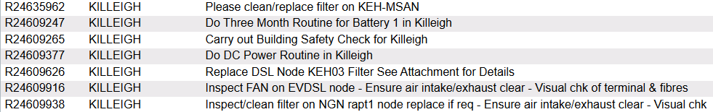

+ Please clean/replace filter on KEH-MSAN
---

Do Three Month Routine for Battery 1 in Killeigh

Overall: 53.64 V
Temperature: 17 °C

1 | 2 | 3 | 4 | 5 | 6 | 7 | 8 | 9 | 10 | 11 | 12 | 13 | 14 | 15 | 16 | 17 | 18 | 19 | 20 | 21 | 22 | 23 | 24
2.21 | 2.21 | 2.21 | 2.21 | 2.21 | 2.21 | 2.21 | 2.20 | 2.20 | 2.21 | 2.21 | 2.21 | 2.21 | 2.20 | 2.21 | 2.21 | 2.21 | 2.21 | 2.21 | 2.21 | 2.21 | 2.21 | 2.21 | 2.21

Do DC Power Routine in Killeigh

Rectifiers | 5
DC Power Load | 29
Boost Voltage | 56.4
Float Voltage | 53.6

Alarm Limits
Low Voltage | 47
High Voltage | 58
High Load | 99%
High Temperature | 30 °C

Low Voltage, High Voltage, High Load and High Temperature alarms were triggered,
But only one power alarm visible to SMC.

